1. Write a program to implement the instanceof operator.
class Sample
{
void display()
{
System.out.println("Test");
}
}
class Sample1
{
void display1()
{
System.out.println("Test1");
}

public static void main(String args[])
{
Sample1 s=new Sample1();
Sample1 ss=new Sample1();
System.out.println(s instanceof Sample1);
}
}

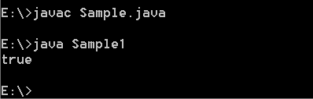

2. Write the program to implement the following Object class methods

2.a -> equals
class Sample
{
void display()
{
System.out.println("Test");
}
}
class Sample1
{
void display1()
{
System.out.println("Test1");
}

public static void main(String args[])
{
Sample1 s=new Sample1();
Sample1 ss=s;
System.out.println(s.equals(ss));
}
}

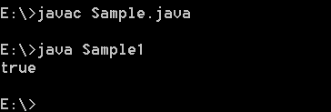

2.b -> getClass()
class Sample
{
void display()
{
System.out.println("Test");
}
}
class Sample1
{
void display1()
{
System.out.println("Test1");
}

public static void main(String args[])
{
Sample1 s=new Sample1();
Sample1 ss=s;
System.out.println(s.getClass());
System.out.println(ss.getClass());
}
}
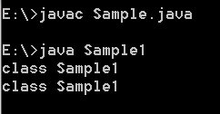
2.c -> hashCode()
class Sample
{
void display()
{
System.out.println("Test");
}
}
class Sample1
{
void display1()
{
System.out.println("Test1");
}

public static void main(String args[])
{
Sample1 s=new Sample1();
Sample1 ss=new Sample1();
System.out.println(s.hashCode());
System.out.println(ss.hashCode());
}
}
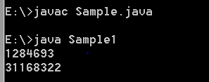

2.d -> toString()
class Sample
{
void display()
{
System.out.println("Test");
}
}
class Sample1
{
void display1()
{
System.out.println("Test1");
}

public static void main(String args[])
{
Sample1 s=new Sample1();
Sample1 ss=new Sample1();
System.out.println(s.toString());
System.out.println(ss.toString());
}
}
